**Python -Assignment -1**

**-18K41A0588**

1. **Develop a code for below scenario**

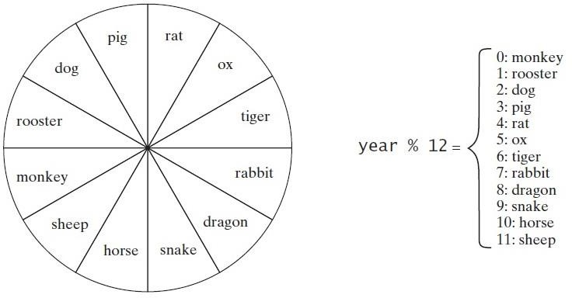

**CODE :**

n=int(input('enter year'))

if n%12==0:

print('monkey')

elif n%12==1:

print('rooster')

elif n%12==2:

print('dog')

elif n%12==3:

print('pig')

elif n%12==4:

print('rat')

elif n%12==5:

print('ox')

elif n%12==6:

print('tiger')

elif n%12==7:

print('rabbit')

elif n%12==8:

print('dragon')

elif n%12==9:

print('snake')

elif n%12==10:

print('horse')

elif n%12==1:

print('sheep')

OUTPUT :

enter year 2013

snake

# 2Q)A Quick Fox Transport Co. wants to develop an application for calculating amount based on distance and weight of goods. The charges (Amount) to be calculated as per rates given below.

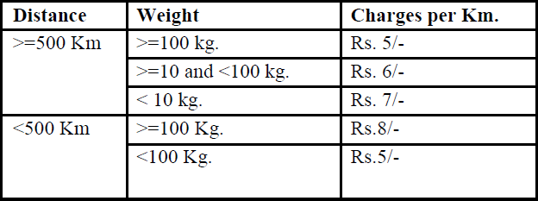

**Input: Distance to be travel: 520 Weight of the goods: 50**

**Output: Amount to be charged: 3120 /-**

**CODE:**

d=int(input('enter distance travelled :'))

weight=int(input('enter weight of goods :'))

if(d>=500):

if(weight>=100):

amount=d*5

elif(weight>=10 and weight<100):

amount=d*6

elif(weight<10):

amount=d*7

elif(d<500):

if(weight>=100):

amount=d*8

elif(weight<100):

amount=d*5

print(amount)

OUTPUT :

enter distance travelled 520

enter weight of goods 50

3120

3)

# The Entertainment Paradise

**A theater in Delhi wants to develop a computerized Booking System. The theater offers different types of seats. The Ticket rates are- Stalls- Rs. 625/-, Circle- Rs.750/-, Upper Class- Rs.850/- and Box- Rs.1000/-. A discount is given 10% of total amount if tickets are purchased on Cash. In case of credit card holders 5% discount is given.**

**Input: Type of Seat: Circle**

**Payment mode: cash Output: Cost of ticket: 675**

seattype=input('enter type of seat :')

paymentmode=input('enter payment mode :')

ic=int(input('enter initial cost of circle seat :'))

if(paymentmode=='cash' and seattype=='circle'):

fc=ic-(ic*10/100)

elif(paymentmode=='credit' and seattype=='circle'):

fc=ic-(ic*5/100)

print(fc)

Output :

enter type of seat : circle

enter payment mode : cash

initial cost of circle seat 750

🡪675.0

# Develop a program that calculates the energy needed to heat water from an initial temperature to a final temperature. Your program should prompt the user to enter the amount of water in kilograms and the initial and final temperatures of the water. The formula to compute the energy is

**Q = M * (finalTemperature – initialTemperature)**

**\* 4184.**

where **M** is the weight of water in kilograms, temperatures are in degrees Celsius, and energy **Q** is measured in joules.

Code :

weight=int(input('enter weight of water in kg :'))

i=int(input('enter initial tempurate in Celsius :'))

l=int(input('enter final tempurate in celsius :'))

q=weight*(l-i)*4184

print(q)

Output :

enter weight of water in kg :40

enter initial tempurate in Celsius : 20

enter final tempurate in Celsius :35

🡪2510400

# 5)

**Develop a program that prompts user to enter month and print**

* 1. **“Winter ” - December ,January and February**
  2. **“Spring” - March ,April and May**
  3. **“summer”- June, July, August**
  4. **“Autumn”- October, September, November**

**Code :**

month=input('enter month :')

if(month=='winter'):

print("December, January and February")

elif(month=='spring'):

... print("March,April and May")

... elif(month=='summer'):

print("June ,July, August")

elif(month=='autumn'):

print(" september,October, November")

Output :

enter month : 'spring'

🡪March,April and May

# write a program that prompts the user to enter weight in pounds and height in inches and displays the BMI

# code :

weight=int(input('enter your weight in kg :'))

height=float(input('enter your height in inches :'))

height=float(height*0.0254)

weight=float(weight*0.45359237)

Bmi=round(weight/height**2)

if(Bmi<18.5):

print('underweight')

elif(18.5<=Bmi<=25.5):

print('Normal')

elif(25.5<=Bmi<=30.0):

print('Overweight')

elif(30.0<=Bmi):

print('obese')

Output :

enter your weight in kg :46

enter your height in inches :5.7

Normal

# Write a program that reads an integer between 100 and 1000 and adds all the digits in the integer ( ex: input 745 # output =16 (7+4+5) )

# Code :

n=int(input('enter a number :'))

sum=0

if(n>=100 and n<=1000):

while(n>0):

riv=n%10

sum=sum+riv

n=n// 10

print(sum)

Output :

enter a number :745

🡺16

# Print all palindrome numbers between 1 to 1000.

# Code :

max=int(input('enter max value :'))

for num in range(1,max):

temp=num

sum=0

while(temp>0):

riv=temp%10

sum=(sum*10)+riv

temp=temp //10

if(num==sum):

print(num)

output :

enter max value :1000

1

2

3

4

5

6

7

8

9

11

22

33

44

55

66

77

88

99

101

111

121

131

141

151

161

171

181

191

202

212

222

232

242

252

262

272

282

292

303

313

323

333

343

353

363

373

383

393

404

414

424

434

444

454

464

474

484

494

505

515

525

535

545

555

565

575

585

595

606

616

626

636

646

656

666

676

686

696

707

717

727

737

747

757

767

777

787

797

808

818

828

838

848

858

868

878

888

898

909

919

929

939

949

959

969

979

989

999

# Print all Armstrong numbers between 1 to 1000.

Code :

max=int(input('enter the max range :'))

for n in range(1,max):

sum=0

temp=n

while(temp>0):

riv=temp%10

sum=sum+riv**3

temp=temp //10

if(n==sum):

print(n)

output :

enter the max range :1000

1

64

125

153

216

370

371

407

729

# 10) Write a Java program which iterates the integers from 1 to

**100. For multiples of three print "Fizz" instead of the number and print "Buzz" for the multiples of five. When number is divided by both three and five, print "fizz buzz”.**

Code :

for i in range(1,100):

if(i%3==0 and i%5==0):

print("Fizz Buzz")

elif(i%3==0):

print("Fizz")

elif(i%5==0):

print("Buzz")

else:

print(i)

output :

1

2

Fizz 4

Buzz Fizz 7

8

Fizz Buzz 11

Fizz 13

14

Fizz Buzz 16

17

Fizz 19

Buzz Fizz 22

23

Fizz Buzz 26

Fizz 28

29

Fizz Buzz 31

32

Fizz 34

Buzz Fizz 37

38

Fizz Buzz 41

Fizz 43

44

Fizz Buzz 46

47

Fizz 49

Buzz Fizz 52

53

Fizz Buzz 56

Fizz 58

59

Fizz Buzz 61

62

Fizz 64

Buzz Fizz 67

68

Fizz Buzz 71

Fizz 73

74

Fizz Buzz 76

77

Fizz 79

Buzz

Fizz 82

83

Fizz Buzz 86

Fizz 88

89

Fizz Buzz 91

92

Fizz 94

Buzz Fizz 97

98

Fizz

# 11) Spider Problem: A spider present at the bottom of the well of height H, needs to get out of it, using the slippery wall of the well. It decides to climb up the well; it goes up U meters and slips down D meters in one single step. So, in each step it covers (U-D) meters, and if the spider gets out of the well by covering U meters in the last step it doesn’t a slip back. For example, if the spider climbs up 5 meters and slips down by 3 meters in a single step, it covers (U - D) m in each step and 96 m in 48 steps, but in the 49th step it climbs up 5 m and reaches out of the well and it will not slip down and the step is counted as one step.

**Code :**

h=int(input('enter the height of well :'))

u=int(input('enter the distance it goes :'))

d=int(input('enter the distance it slips :'))

dist=0

step=0

while(True):

dist=dist+u

step=step+1

if(dist>h):

break

dist=dist-d

print(step)

Output :

enter the height of well :200

enter the distance it goes :50

enter the distance it slips :15

🡪7